Project Development Phase
Model Performance Test

Date | 30 September 2026
Team ID | SWTID-2026-8886
Project Name | Implement Client Script and UI Policy for Incident
Maximum Marks

Model Performance Testing:
Project team shall fill the following information in model performance testing template.
S.No. | Parameter | Values | Screenshot
1 | Configuration summary | ServiceNow Incident UI Policy plus three Client Scripts. CRM/model metrics do not apply to this platform workflow. | Conceptual form diagram
2 | Accuracy | No model training or accuracy metric applies. Functional outcomes are pending UAT. | Not applicable
3 | Confidence score | No object recognition or confidence score applies. Use the eight UAT cases. | Not applicable

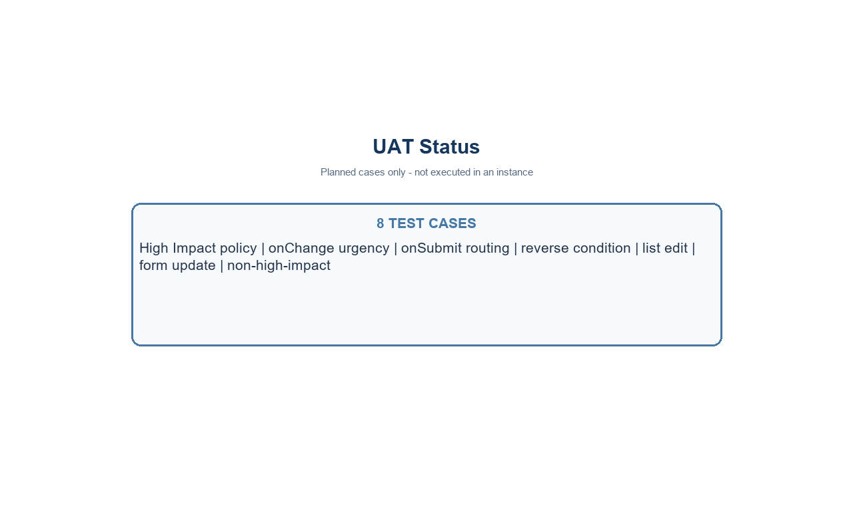
Conceptual Incident form - not a live screenshot
Project note: values use the standard Incident choices where Impact 1 and Urgency 1 represent High. Confirm field names and values in the target instance.

